- Please add your private key(.pfx or P12 only) in google browser, in case you are doing 2-way ssl.

- Add postman extension in Google Chrome and pass below url and headere as below:
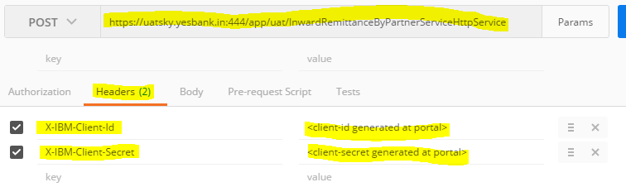
- Add Authorization value as below:
Username: testclient
Password: test@123
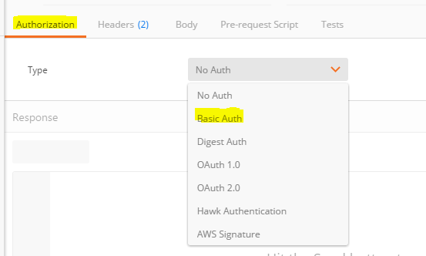

Pass value as:
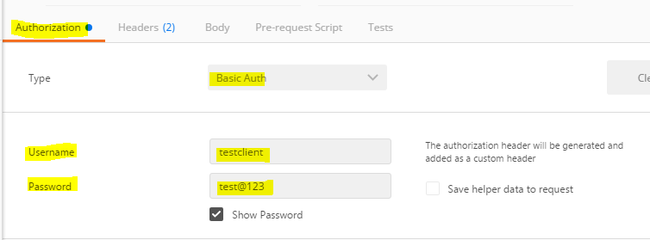

- Pass sample request message(shared by testing team) as Body and you will get response accordingly. Please find below sample request.
